CSA0976 programming in java

Assignment 1

1.program for squareroot : code

import java.util.\*;

class squareroot

{

public static void main(String[] args)

{

System.out.print("Enter a number: ");

Scanner sc = new Scanner(System.in);

int n = sc.nextInt();

System.out.println("The square root of "+ n+ " is:"+squareRoot(n));

}

public static int squareRoot(int num)

{

int t;

int sqrtroot=num/2;

do

{

t=sqrtroot;

sqrtroot=(t+(num/t))/2;

}

while((t-sqrtroot)!= 0);

return sqrtroot; }

}

Output:-

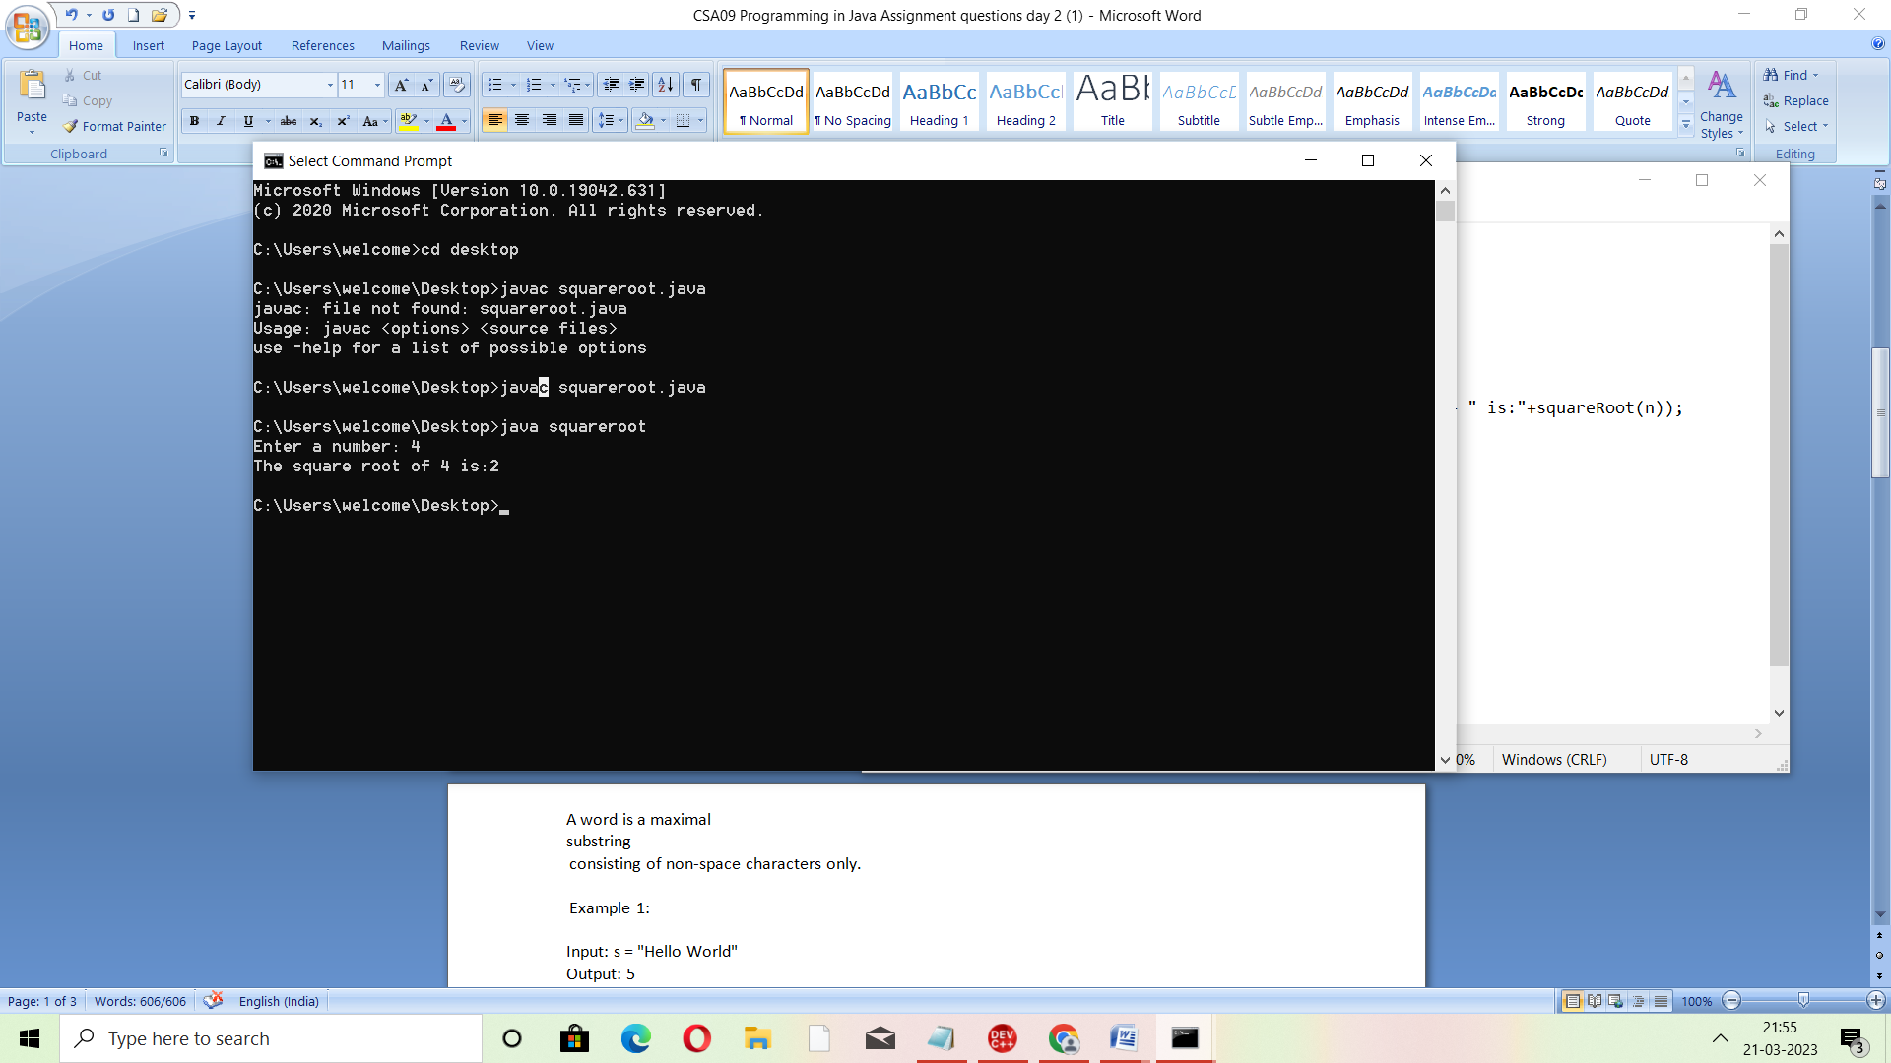

2.program to verified the given number is palindrome or not:- code

import java.io.\*;

import java.util.\*;

class palindrome

{

public static void main(String arg[])

{

String s,b="";

char d;

Scanner c=new Scanner(System.in);

System.out.print("Enter a Number :");

s=c.nextLine();

for(int i=0;i<s.length();i++)

{

d=s.charAt(i);

b=d+b;

}

if(s.equals(b))

{

System.out.print("The given number is palindrome");

}

else

{

System.out.print("The given number is not palindrome");

}

}

}

Output: